**CYCLISTIC BIKE SHARE REPORT CARRIED OUT BY ETINIABASI**

**BACKGROUND**

Cyclistic, a bike-share company launched in 2016, now operates a fleet of 5,824 bikes across 692 geo-tracked stations in Chicago. The program allows riders to unlock a bike from one station and return it to any other within the network. With a focus on flexibility, Cyclistic offers three pricing plans: single-ride passes, full-day passes, and annual memberships. **Casual riders** are those who opt for single-ride or full-day passes, while annual memberships are purchased by **Cyclistic members**.

Although this flexibility has attracted a wide customer base, financial analysis shows that annual members are significantly more profitable than casual riders. To maximize growth, Cyclistic now aims to convert casual riders into annual members. These riders are already familiar with the program and rely on it for their mobility needs, making them a key target audience for conversion.

To achieve this, the team seeks to understand how annual members and casual riders differ in their bike usage, why casual riders might choose to become members, and how digital media can influence their decisions. This report will explore the first question: **How do annual members and casual riders use Cyclistic bikes differently?** Findings from this analysis will shape marketing strategies to drive more annual memberships and support Cyclistic’s future growth.

**KEY QUESTION**

**How do annual members and casual riders use Cyclistic bikes differently?**

**DATA PREPARATION AND CLEANING**

**DATASET DESCRIPTION**

**The Dataset(s) are publicly available at** [Index of bucket "divvy-tripdata"](https://divvy-tripdata.s3.amazonaws.com/index.html) and I used the 2024 data files, showing data collected between January 2024 and November 2024

**Microsoft Excel** and **PowerBI** were used for the cleaning, analysis and transformation

* I loaded the datasets on PowerQuery where I transformed and combined the data at once, in order to save time.
* The raw data contained duplicates, null values, and invalid entries, all of which were removed to ensure accuracy.
* Unnecessary columns, such as latitude and longitude coordinates, were excluded since they were not relevant for this analysis.
* Columns were renamed (e.g., "member_casual" to "member_type") for clarity.
* Additional columns were created, including:
  + **Day of the Week:** Extracted from the ride start time.
  + **Ride Time:** Calculated as the duration of each ride.
  + **Month:** Derived to analyze seasonal trends.

**DATA ANALYSIS**

Data Analysis and Visualizations was carried out on PowerBI (due to file size) and the following insights were discovered:

1. A total of **68,950** hours was logged in bike rides during the year 2024.
2. The longest recorded bike ride lasted 1.08 hours
3. Members accounted for 62.81% of users, while casual riders made up 37.19%.

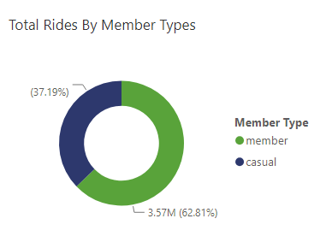

1. 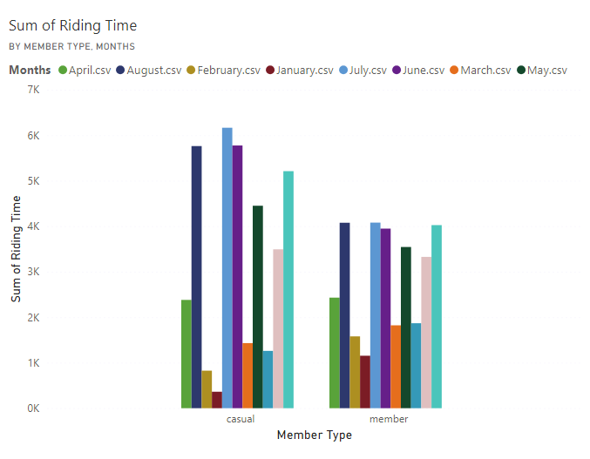 **Seasonal Trends:** The highest number of rides occurred during the summer months (June–September), with July seeing the peak usage.
2. Most bike users used classic bikes and electric bikes.
   * **Members** predominantly used electric bikes.
   * **Casual Riders** mostly opted for classic bikes.
   * Electric scooters were the least used across both groups.

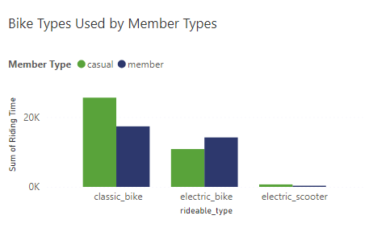

1. 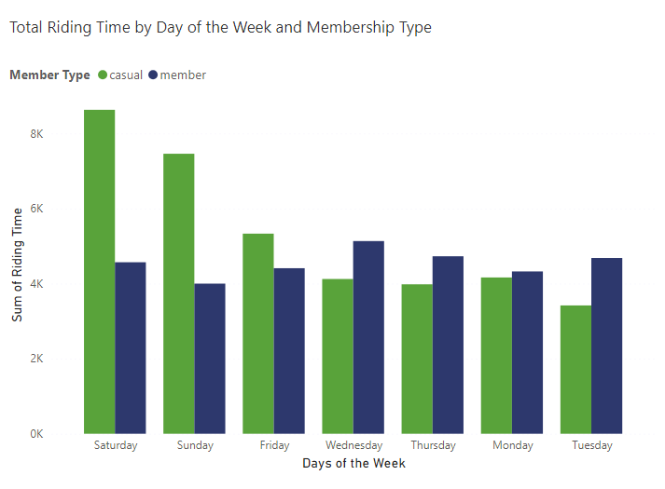Casual riders mostly rode during the weekends (Saturday and Sunday)

Members rode the least during weekends and rode during weekends. It is safe to say that members mostly use the bike rides for commute to work

**CONCLUSIONS AND RECOMMENDATIONS**

* With summer being the busiest season, launch promotions in the months leading up to summer to attract more casual riders and encourage them to convert to memberships.
* Highlight the cost-effectiveness and convenience of annual memberships for daily commuters, as members often ride on weekdays for work purposes.
* Since casual riders primarily ride on weekends, marketing campaigns should focus on highlighting the benefits of annual memberships for recreational use, such as discounted rates for frequent weekend riders.

